**University of Michigan – Dearborn**

**CIS 200 – Computer Science 2**

**Lab# 2**

Nahrin Sharna

[nsharna@umich.edu](mailto:nsharna@umich.edu)

1/27/2019

**Windows Source Code**

/*

Author: Nahrin Sharna

Creation Date: 01/26/2019

Modification Date: 01/26/2019

Purpose: To display the monthly sales of two stores

*/

#include<iostream>

#include<iomanip>

using namespace std;

const int NUM_DEPTS = 2;

const int NUM_STORES = 2;

const int NUM_MONTHS = 12;

void printMonthlySales(float[][NUM_MONTHS][NUM_DEPTS], int, int);

int main() {

int monthValue;

char choice;

int value;

float storeMonthlySales[NUM_STORES][NUM_MONTHS][NUM_DEPTS] = {

{{1.1, 1.2}, {1.3, 1.4}, {1.5, 1.6}, {1.7, 1.8}, {1.9, 2.0}, {2.1, 2.2}, {2.1, 2.2}, {2.3, 2.4}, {2.5, 2.6}, {2.7, 2.8}, {2.9, 3.0}, {3.1, 3.2} },

{{3.1, 3.2}, {3.3, 3.4}, {3.5, 3.6}, {3.7, 3.8}, {3.9, 4.0}, {4.1, 4.2},{2.1, 2.2}, {2.3, 2.4}, {2.5, 2.6}, {2.7, 2.8}, {2.9, 3.0}, {3.1, 3.2} }

};

do {

cout << "Would you like to check the total sales for a specific month (Y or N): ";

cin >> choice;

switch (toupper(choice))

{

case 'Y':

{

cout << "Please enter a month value(1-12): ";

cin >> monthValue;

if (monthValue >= 1 && monthValue <= 12)

printMonthlySales(storeMonthlySales, 2, monthValue);

else

cout << "Error!! Invalid month value has been input." << endl;

break;

}

case 'N':

cout << "The program quits. Thank you!!!" << endl;

break;

default:

cout << "Error! Invalid choice." << endl;

}

} while (toupper(choice) != 'N');

system("pause");

return 0;

}

void printMonthlySales(float a[][NUM_MONTHS][NUM_DEPTS], int stores, int month) {

float monthsaleforstore1 = a[0][month][0] + a[0][month][1];

float monthsaleforstore2 = a[1][month][0] + a[1][month][1];

float colSum1 = a[0][month][0] + a[1][month][0];

float colSum2 = a[0][month][1] + a[1][month][1];

float monthlySales = monthsaleforstore1 + monthsaleforstore2;

cout << setw(16) << "Dept#" << setw(13) << "Dept# " << setw(16) << "StoreTotal" << endl << endl;

cout << "store1" << setw(9) << a[0][month][0] << setw(12) << a[0][month][1] << setw(14) << monthsaleforstore1 << endl << endl;

cout << "store2" << setw(9) << a[1][month][0] << setw(12) << a[1][month][1] << setw(14) << monthsaleforstore2 << endl << endl;

cout << "Dept Total" << setw(5) << colSum1 << setw(12) << colSum2 << setw(14) << monthlySales << endl << endl;

}

**Windows Test Plan:**

|  |  |  |  |  |  |  |
| --- | --- | --- | --- | --- | --- | --- |
| Test # | Valid / Invalid Data | Description of test | Input Value | Expected Output | Actual Output | Test Pass / Fail |
| 1 | Valid | User wants to check total sales for a month | Y | Asking for a month value | “Please enter a month value (1-12): ” | Pass |
| 2 | Invalid | User input an invalid choice | o | Error message | “Error! Invalid choice” | Pass |
| 3 | Valid | User doesn’t want to check the total sales | N | A message | “The program quits. Thank you!” | Pass |
| 4 | Valid | User input month value between 1-12 | 4 | Show total sales of each stores, show overall total sales |  | Pass |
| 5 | Invalid | User input invalid number for a month value | 17 | Show an error message | “Error!! Invalid month value has been input” | Pass |

**Windows Screenshots:**

1. Choice ‘Y’:

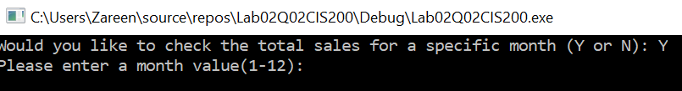

1. Invalid Choice:



1. Choice ‘N’:

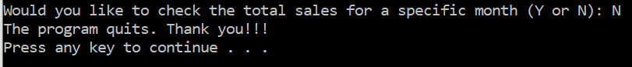

1. Valid Month Value:

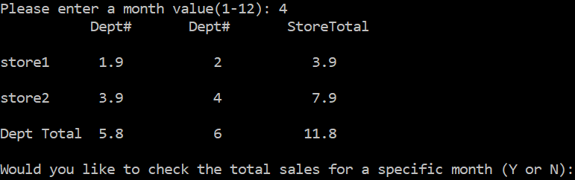

1. Invalid Month Value:

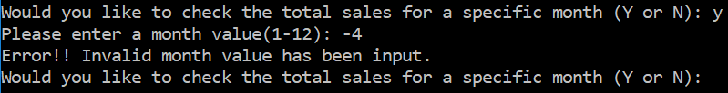

**Unix Test Plans:**

|  |  |  |  |  |  |  |
| --- | --- | --- | --- | --- | --- | --- |
| Test # | Valid / Invalid Data | Description of test | Input Value | Expected Output | Actual Output | Test Pass / Fail |
| 1 | Valid | User wants to check total sales for a month | y | Asking for a month value | “Please enter a month value (1-12):” | Pass |
| 2 | Invalid | User input an invalid choice | g | Error message | “Error! Invalid choice” | Pass |
| 3 | Valid | User doesn’t want to check the total sales | n | A message | “The program quits. Thank you!” | Pass |
| 4 | Valid | User input month value between 1-12 | 2 | Show total sales of each stores, show overall total sales |  | Pass |
| 5 | Invalid | User input invalid number for a month value | 17 | Show an error message | “Error!! Invalid month value has been input” | Pass |

**Unix Screenshots:**

1. Choice ‘Y’:

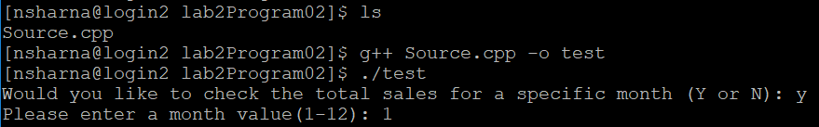

1. Invalid Choice:



1. Choice ‘N’:



1. Valid Month Value:

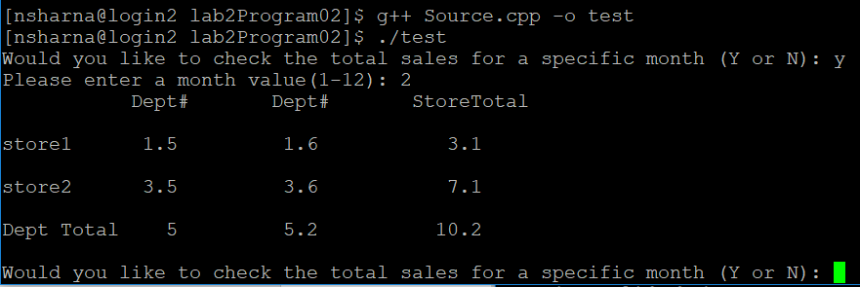

1. Invalid Month Value:

